Create Docker Networks and Run Containers Using the Same Port
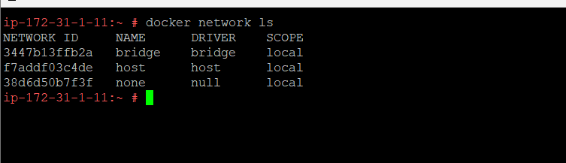
Without creating any docker network
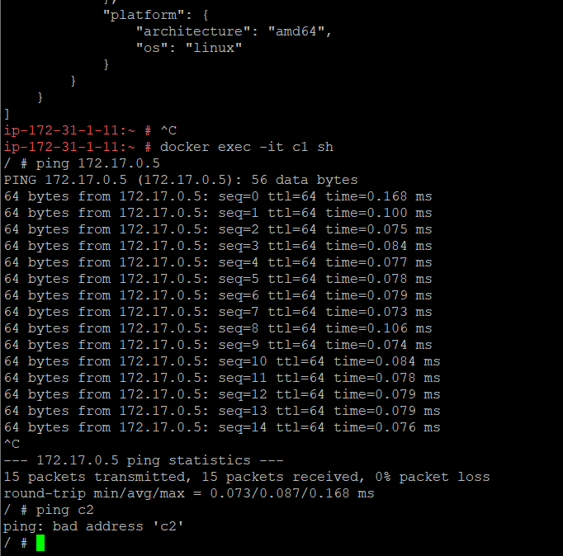
A network with driver bridge driver siva_net created
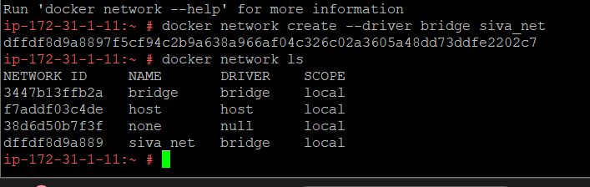
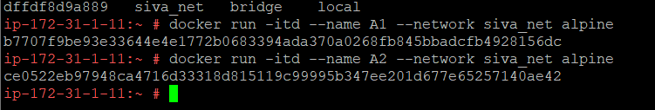
After it is
